# Platform

Proteus_8.9_SP2 (stm32f103c6)

Keil MDK5

# 1. download STM32F103C6 library (version 3.5.0)

https://www.st.com/content/st_com/en/products/embedded-software/mcu-mpu-embedded-software/stm32-embedded-software/stm32-standard-peripheral-libraries/stsw-stm32054.html

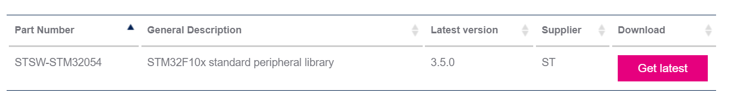

# 2. copy file to project

new BOOT, FreeRTOS, Interrupt, Library, Src directory in project directory. copy file

1. copy to boot directory

STM32F10x_StdPeriph_Lib_V3.5.0\Libraries\CMSIS\CM3\CoreSupport\core_cm3.c

STM32F10x_StdPeriph_Lib_V3.5.0\Libraries\CMSIS\CM3\CoreSupport\core_cm3.h

STM32F10x_StdPeriph_Lib_V3.5.0\Libraries\CMSIS\CM3\DeviceSupport\ST\STM32F10x\startup\arm\startup_stm32f10x_ld.s

2.copy to library directory

STM32F10x_StdPeriph_Lib_V3.5.0\Libraries\STM32F10x_StdPeriph_Driver\

STM32F10x_StdPeriph_Lib_V3.5.0\Libraries\CMSIS\CM3\DeviceSupport\ST\STM32F10x\stm32f10x.h

STM32F10x_StdPeriph_Lib_V3.5.0\Libraries\CMSIS\CM3\DeviceSupport\ST\STM32F10x\system_stm32f10x.c

STM32F10x_StdPeriph_Lib_V3.5.0\Libraries\CMSIS\CM3\DeviceSupport\ST\STM32F10x\system_stm32f10x.h

3.copy to interrupt diectory

STM32F10x_StdPeriph_Lib_V3.5.0\Project\STM32F10x_StdPeriph_Examples\GPIO\IOToggle\stm32f10x_it.c

STM32F10x_StdPeriph_Lib_V3.5.0\Project\STM32F10x_StdPeriph_Examples\GPIO\IOToggle\stm32f10x_it.h

4.copy to src directory

STM32F10x_StdPeriph_Lib_V3.5.0\Project\STM32F10x_StdPeriph_Examples\GPIO\IOToggle\main.c

STM32F10x_StdPeriph_Lib_V3.5.0\Project\STM32F10x_StdPeriph_Examples\GPIO\IOToggle\stm32f10x_conf.h

add file to project

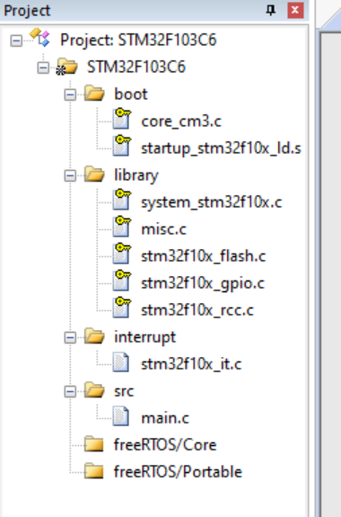

define and config

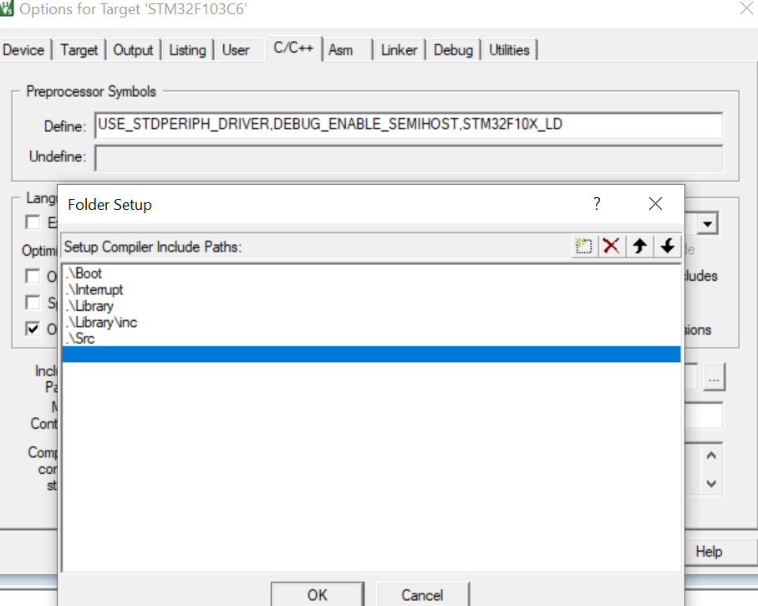

# 3. modify and test

修改Main文件

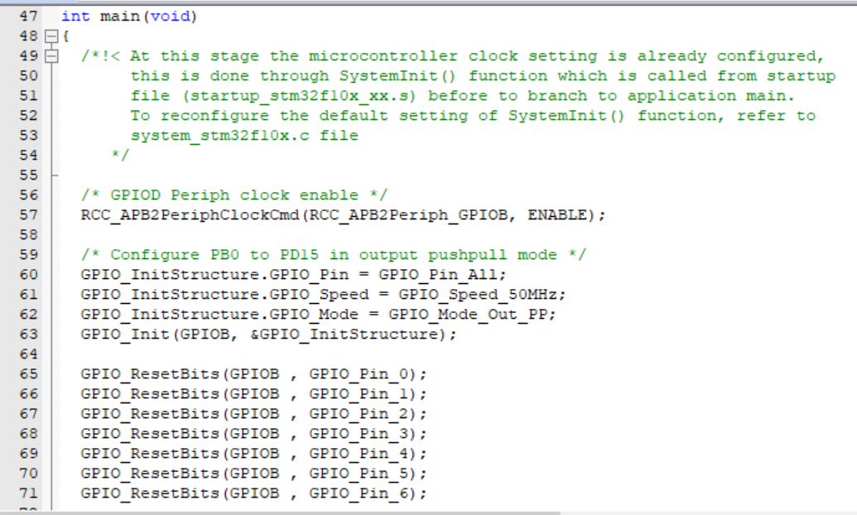

测试结果

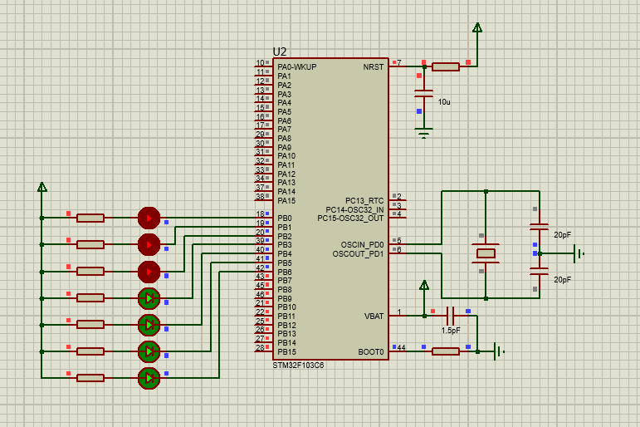

# 4. porting UCOS

1. download UCOS

https://github.com/weston-embedded/uC-OS3

https://github.com/weston-embedded/uC-CPU

https://github.com/weston-embedded/uC-LIB

2. porting uc-lib

uC-LIB-develop\lib_ascii.c

uC-LIB-develop\lib_ascii.h

uC-LIB-develop\lib_def.h

uC-LIB-develop\lib_math.c

uC-LIB-develop\lib_math.h

uC-LIB-develop\lib_mem.c

uC-LIB-develop\lib_mem.h

uC-LIB-develop\lib_str.c

uC-LIB-develop\lib_str.h

uC-LIB-develop\Cfg\Template\lib_cfg.h

3. porting ucos-cpu

uC-CPU-develop\cpu_cache.h

uC-CPU-develop\cpu_core.c

uC-CPU-develop\cpu_core.h

uC-CPU-develop\cpu_def.h

//Cortex-M0 ARM-v6的架构

//Cortex-M3、 Cortex-M4和 Cortex-M7等都是采用的ARM-v7的架构

uC-CPU-develop\ARM-Cortex-M\ARMv7-M\ARM\cpu_a.asm

uC-CPU-develop\ARM-Cortex-M\ARMv7-M\ARM\cpu.h

uC-CPU-develop\ARM-Cortex-M\ARMv7-M\cpu_c.c

uC-CPU-develop\Cfg\Template\cpu_cfg.h

uC-CPU-develop\BSP\Template\bsp_cpu.c

4. porting ucos-source

uC-OS3-develop\Source\os.h

uC-OS3-develop\Source\os_cfg_app.c

uC-OS3-develop\Source\os_core.c

uC-OS3-develop\Source\os_dbg.c

uC-OS3-develop\Source\os_flag.c

uC-OS3-develop\Source\os_mem.c

uC-OS3-develop\Source\os_msg.c

uC-OS3-develop\Source\os_mutex.c

uC-OS3-develop\Source\os_prio.c

uC-OS3-develop\Source\os_q.c

uC-OS3-develop\Source\os_sem.c

uC-OS3-develop\Source\os_stat.c

uC-OS3-develop\Source\os_task.c

uC-OS3-develop\Source\os_tick.c

uC-OS3-develop\Source\os_time.c

uC-OS3-develop\Source\os_tmr.c

uC-OS3-develop\Source\os_trace.h

uC-OS3-develop\Source\os_type.h

uC-OS3-develop\Source\os_var.c

5. porting ucos-portable

uC-OS3-develop\Cfg\Template\os_app_hooks.c

uC-OS3-develop\Cfg\Template\os_app_hooks.h

uC-OS3-develop\Cfg\Template\os_cfg.h

uC-OS3-develop\Cfg\Template\os_cfg_app.h

uC-OS3-develop\Ports\ARM-Cortex-M\ARMv7-M\os_cpu_c.c

uC-OS3-develop\Ports\ARM-Cortex-M\ARMv7-M\ARM\os_cpu_a.asm

uC-OS3-develop\Ports\ARM-Cortex-M\ARMv7-M\ARM\os_cpu.h

uC-OS3-develop\Template\bsp_os_dt.c

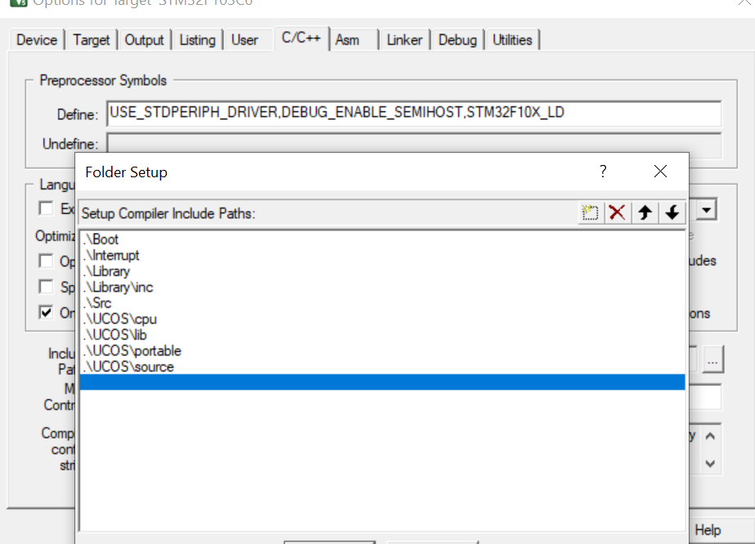

修改os_cpu.c

#include "os.h"

修改 cpu_cfg.h

#if 1

#define CPU_CFG_NVIC_PRIO_BITS 4u

#endif

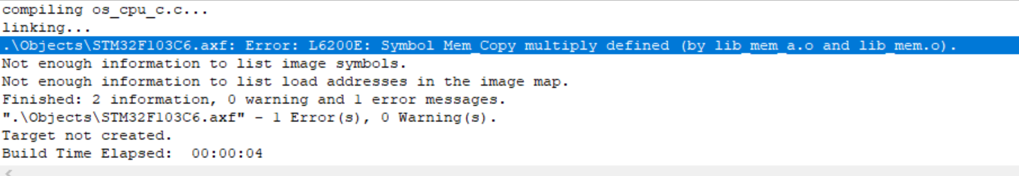

删除lib_mem_a.asm